**Deck of Cards**

**ACE = 14**

**KING = 13**

**QUEEN = 12**

**JACK= 11**

**HEART = CARDIO**

**Mountain Climbers**

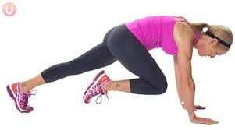

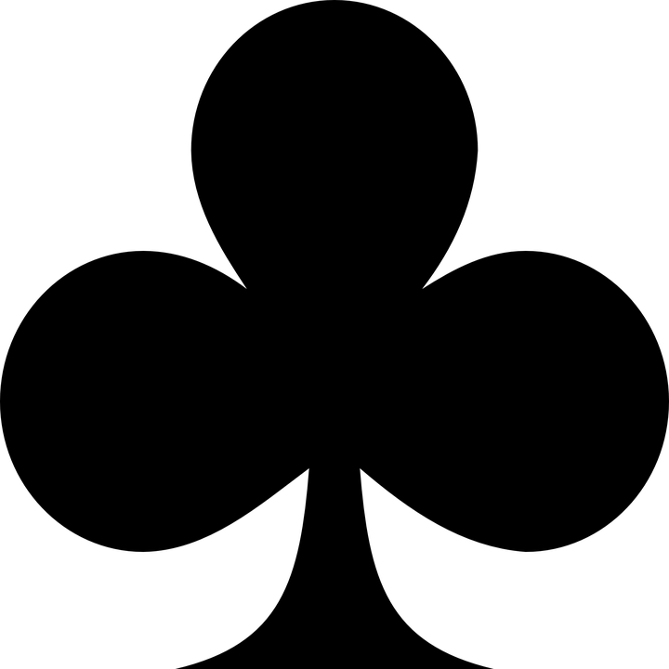**CLUBS = LEGS**

**Body Weight Squats or Jumps Squats**

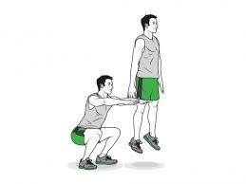

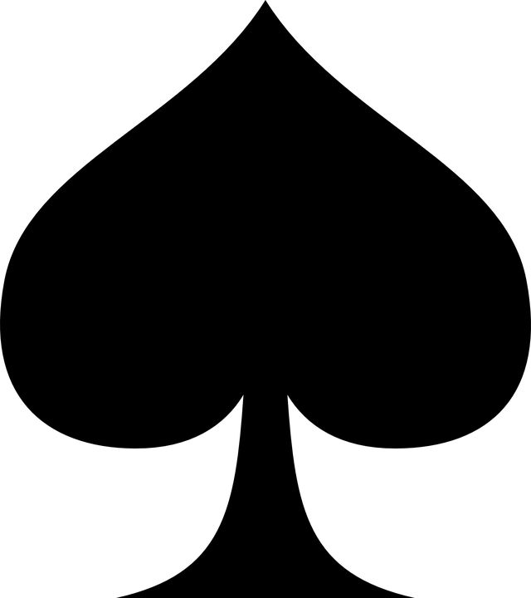**SPADES = LEGS**

**Jumping Jacks**

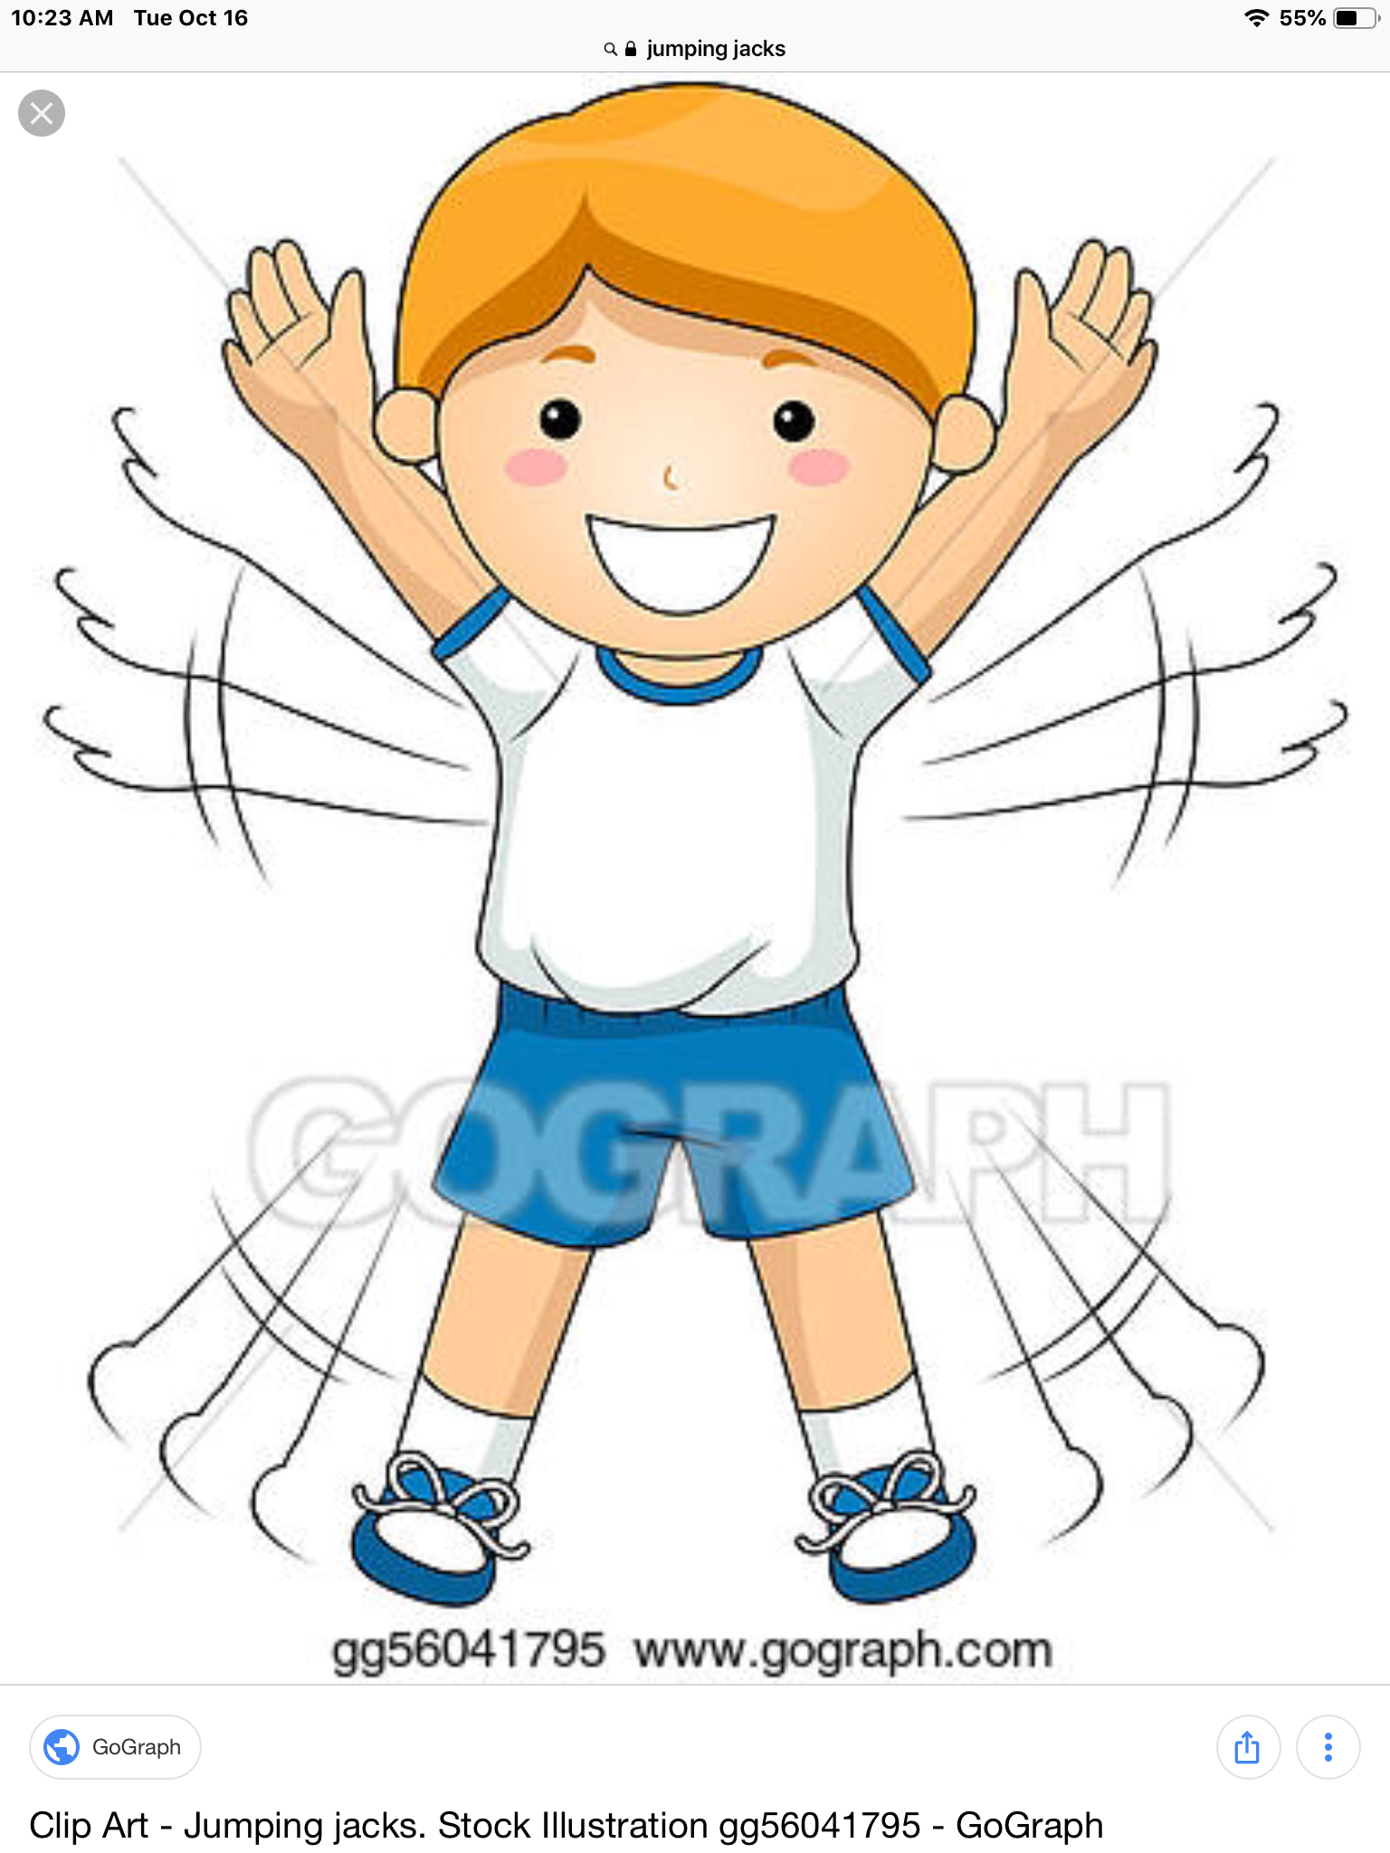

**DIAMONDS = Shoulder touches for arms**

